MODELING CuS–CdSe SOLAR CELL S-SHAPED I-V CHARACTERISTICS
Oleg Olikh, Dmytro Krasko
Taras Shevchenko National University of Kyiv, Kyiv, Ukraine
phone: +380673169020, e-mail: olikh@univ.kiev.ua
The process of designing practical photovoltaic applications calls for the availability of dc lumped-parameter equivalent circuit models. Such models help in understanding the work principles of solar cells (SCs), interpreting the I–V characteristics and device performances, and optimizing the performance of SCs, through a quantitative simulation¹. Our work is focused on the determination of the proper equivalent model of CuS–CdSe structure.
The p+-n thin film Cu_{1.8}S–CdSe structure is used in the investigation with the initial thickness of each layer 15 nm and 7μm, respectively. p+ is the collector layer with p = 10²¹ cm⁻³ while 10¹⁵ cm⁻³ is the n of the base layer. The I-V characteristics were measured over a temperature range 290-340 K. Fig. 1 shows that the electrical characteristics of the investigated solar cell are more complex than conventional photovoltaic devices, varying from an ideal ‘J’ shape to a non-ideal ‘S’ shape with a ‘kink’ in the I-V plot when under illumination.
The model from de Castro², which consist of two opposite polarity diodes D1 and D2 with shunt resistors R_{SH,1} and R_{SH,2}, was chosen as an initial approximation. The I-V characteristics were fitted by the exact closed form analytical solution^{3,4}:
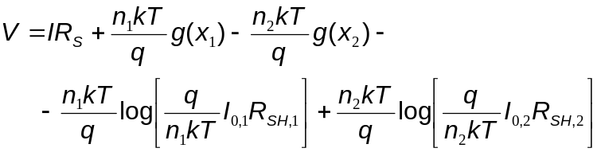, (1)
where R_{S} is the series resistance, n_{i}, I_{0,i} – the ideality factor and saturation current of i-th diode, I_{PH} – is the photocurrent, 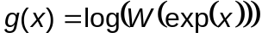, W - Lambert W function,
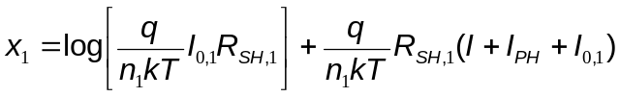, (2)
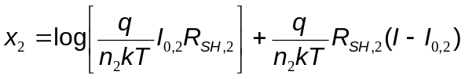. (3)
The fitting was done by using differential evolution method.
The analysis has been shown that i) the series resistance value is less than 10⁻⁹ Ohm; ii) I₀₂ <10⁻²⁵ A in the dark case and opposite second diode must be omitted the dark case. The final equivalent circuit models are shown in Fig.2.
The extracted temperature dependences of diodes parameters are shown in Fig. 3. One can see that the temperature dependence of the D1 saturation current is the same as expected in recombination–tunneling current model⁵:
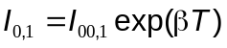. (4)
The shunt resistances are thermoactivated:
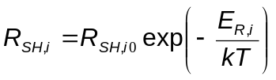. (5)
It should be noted that in the dark case the knee at about 310~K is observed at temperature dependencies of parameters. Hence the current mechanism changes at this temperature value. Fig. 3 show that the charge transport mechanism in both illuminated and dark thin film Cu_{1.8}S–CdSe structure is the same at T<310~K, whereas those are different at higher temperature.
It is known¹ the S-shaped I–V curve could be induced by different reasons: interfacial dipole, charge accumulation at interface, unbalanced charge transportation, and electrode/active layer interfacial Schottky barriers. The obtained results obtained testify that these processes depend on temperature and illumination.

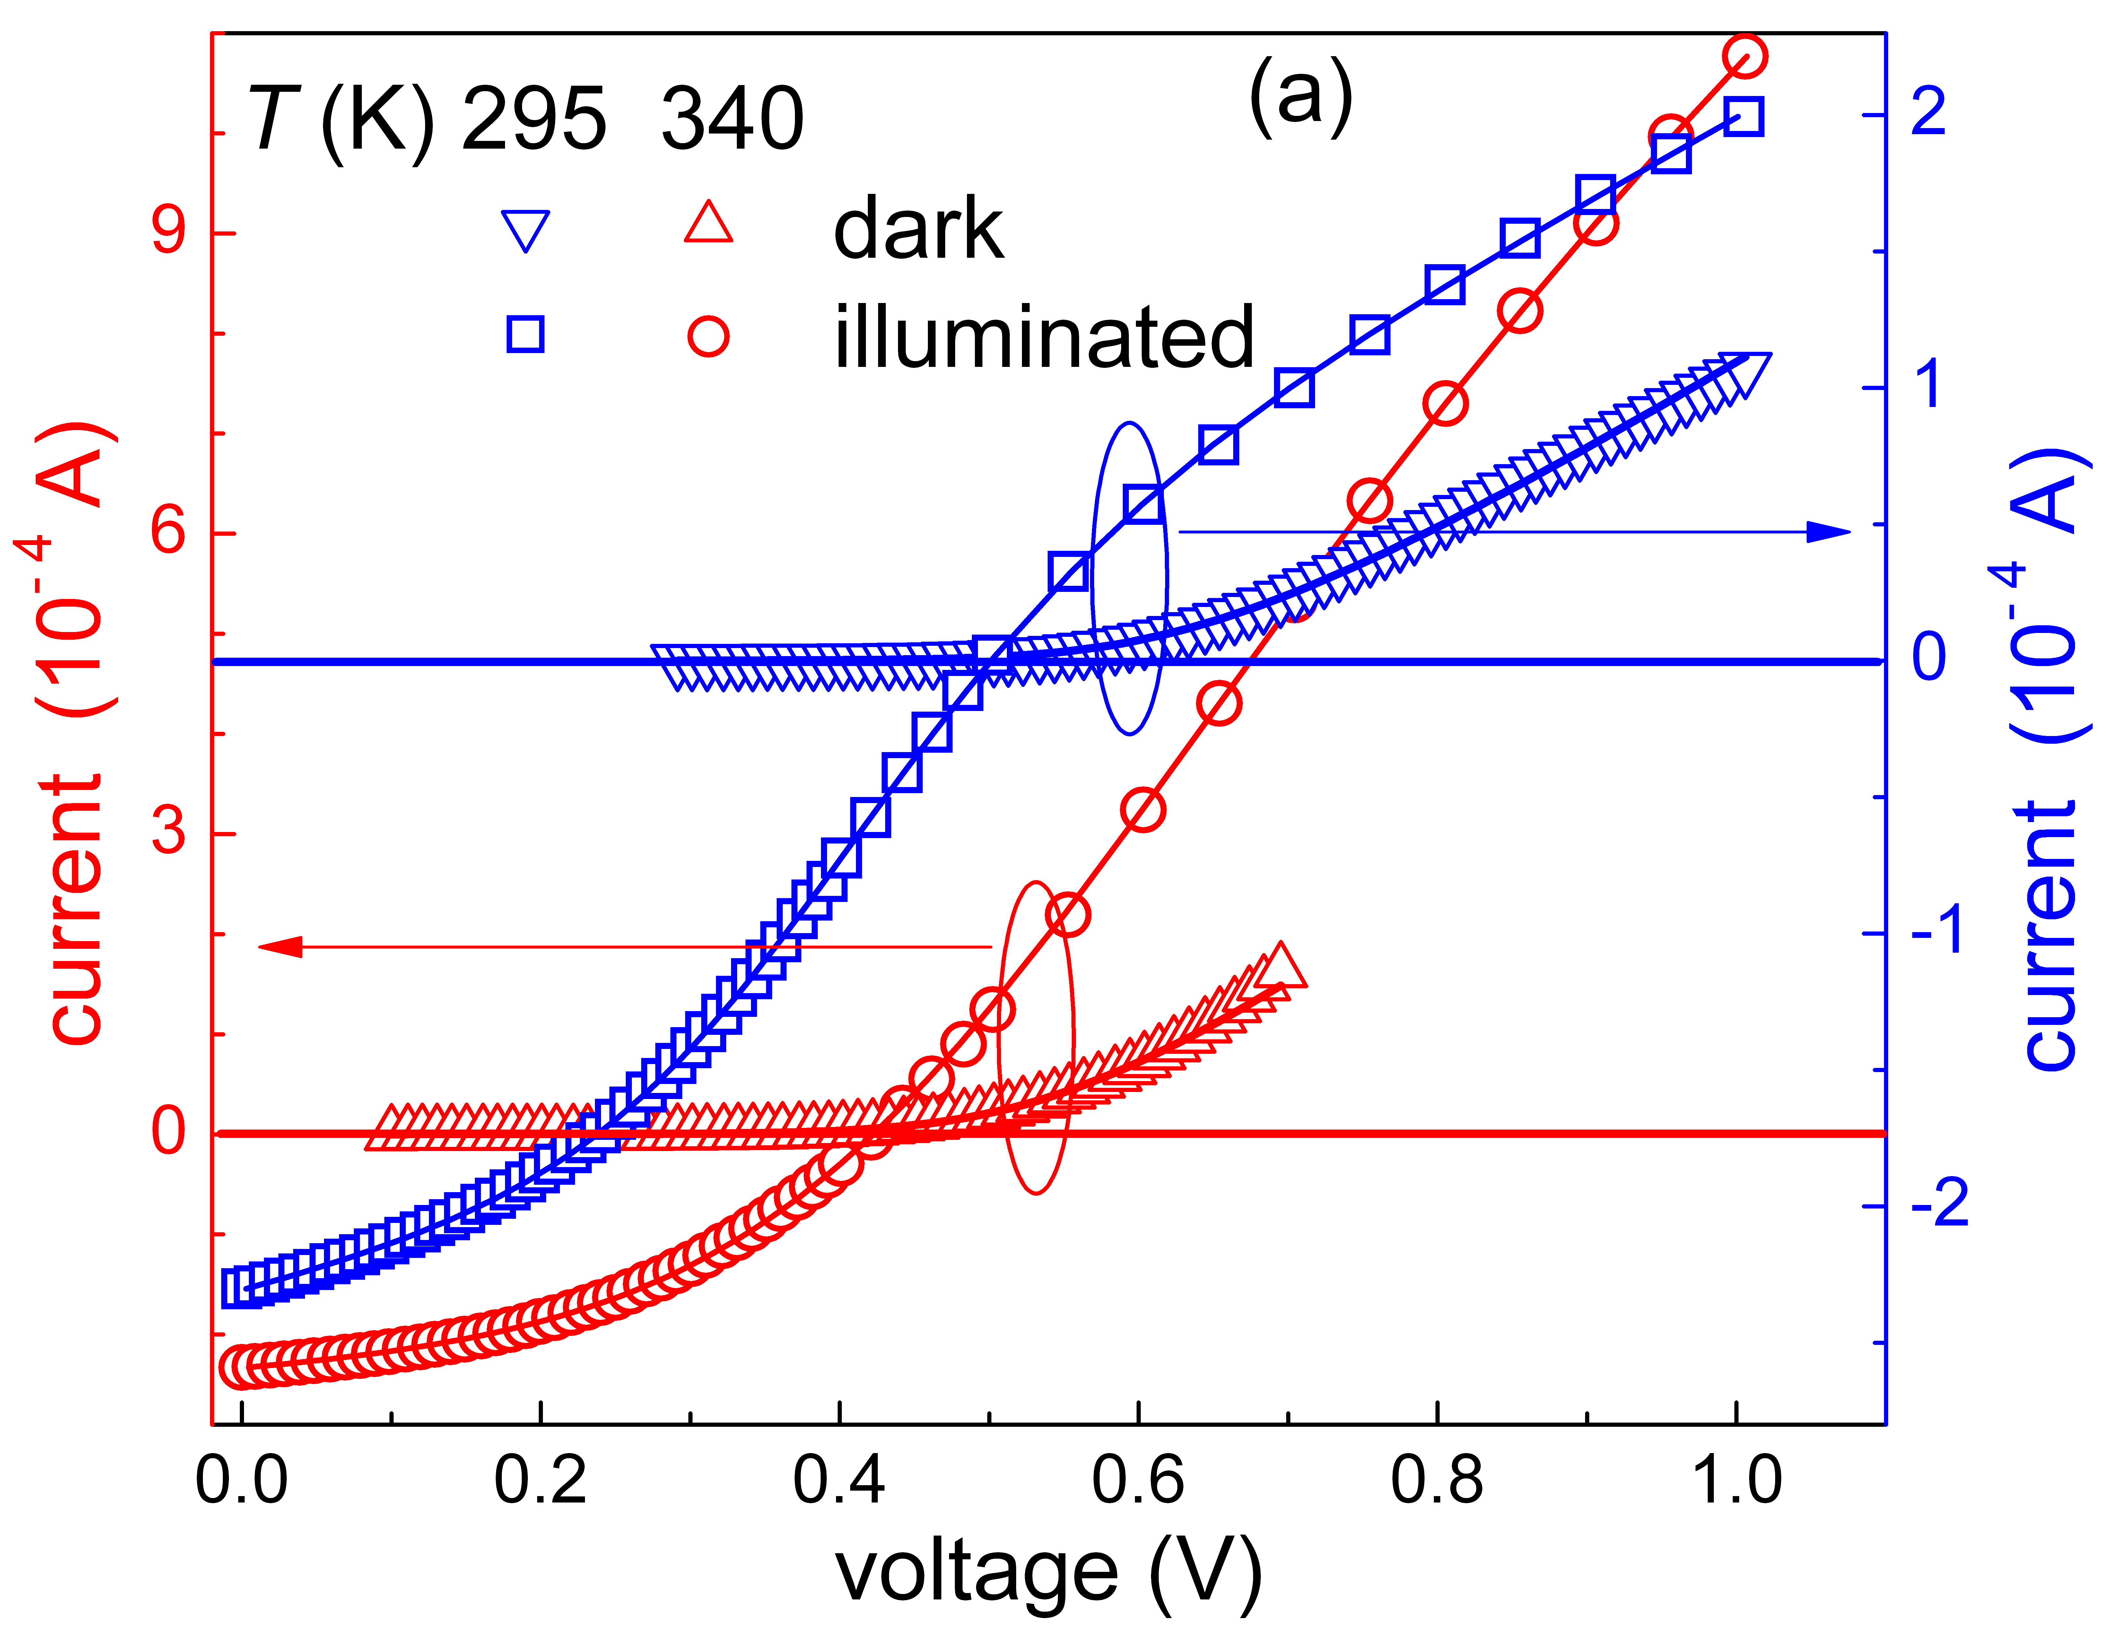 | 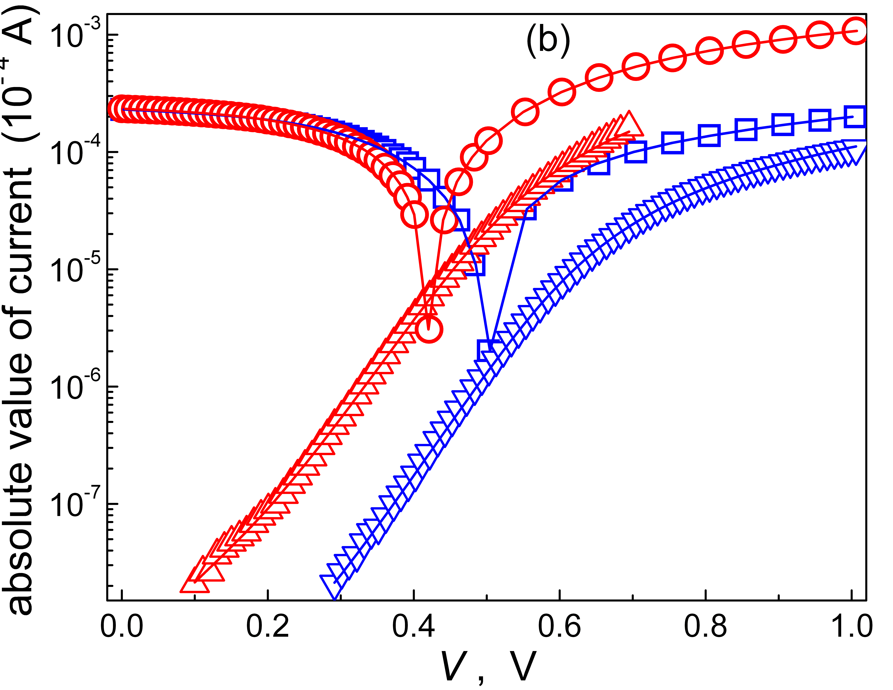
Fig.1. The dark (triangles) and illuminated (circles and squares) I-V curves of Cu_{1.8}S–CdSe solar cell. The experimental (marks) and fitted (solid lines) results are presented.

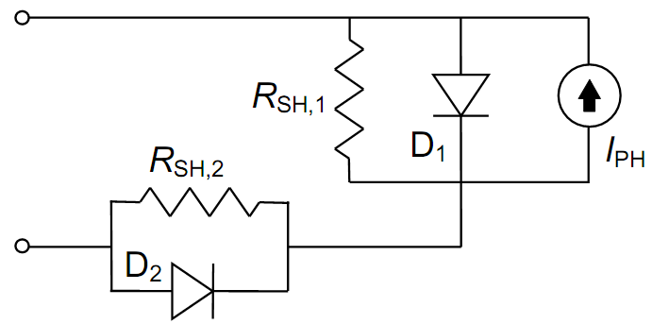 | 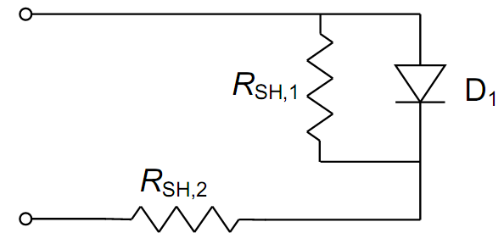
Fig.2. The proposed DC lumped-parameter equivalent circuit model of Cu_{1.8}S–CdSe solar cell under illumination (left) and dark condition (right).

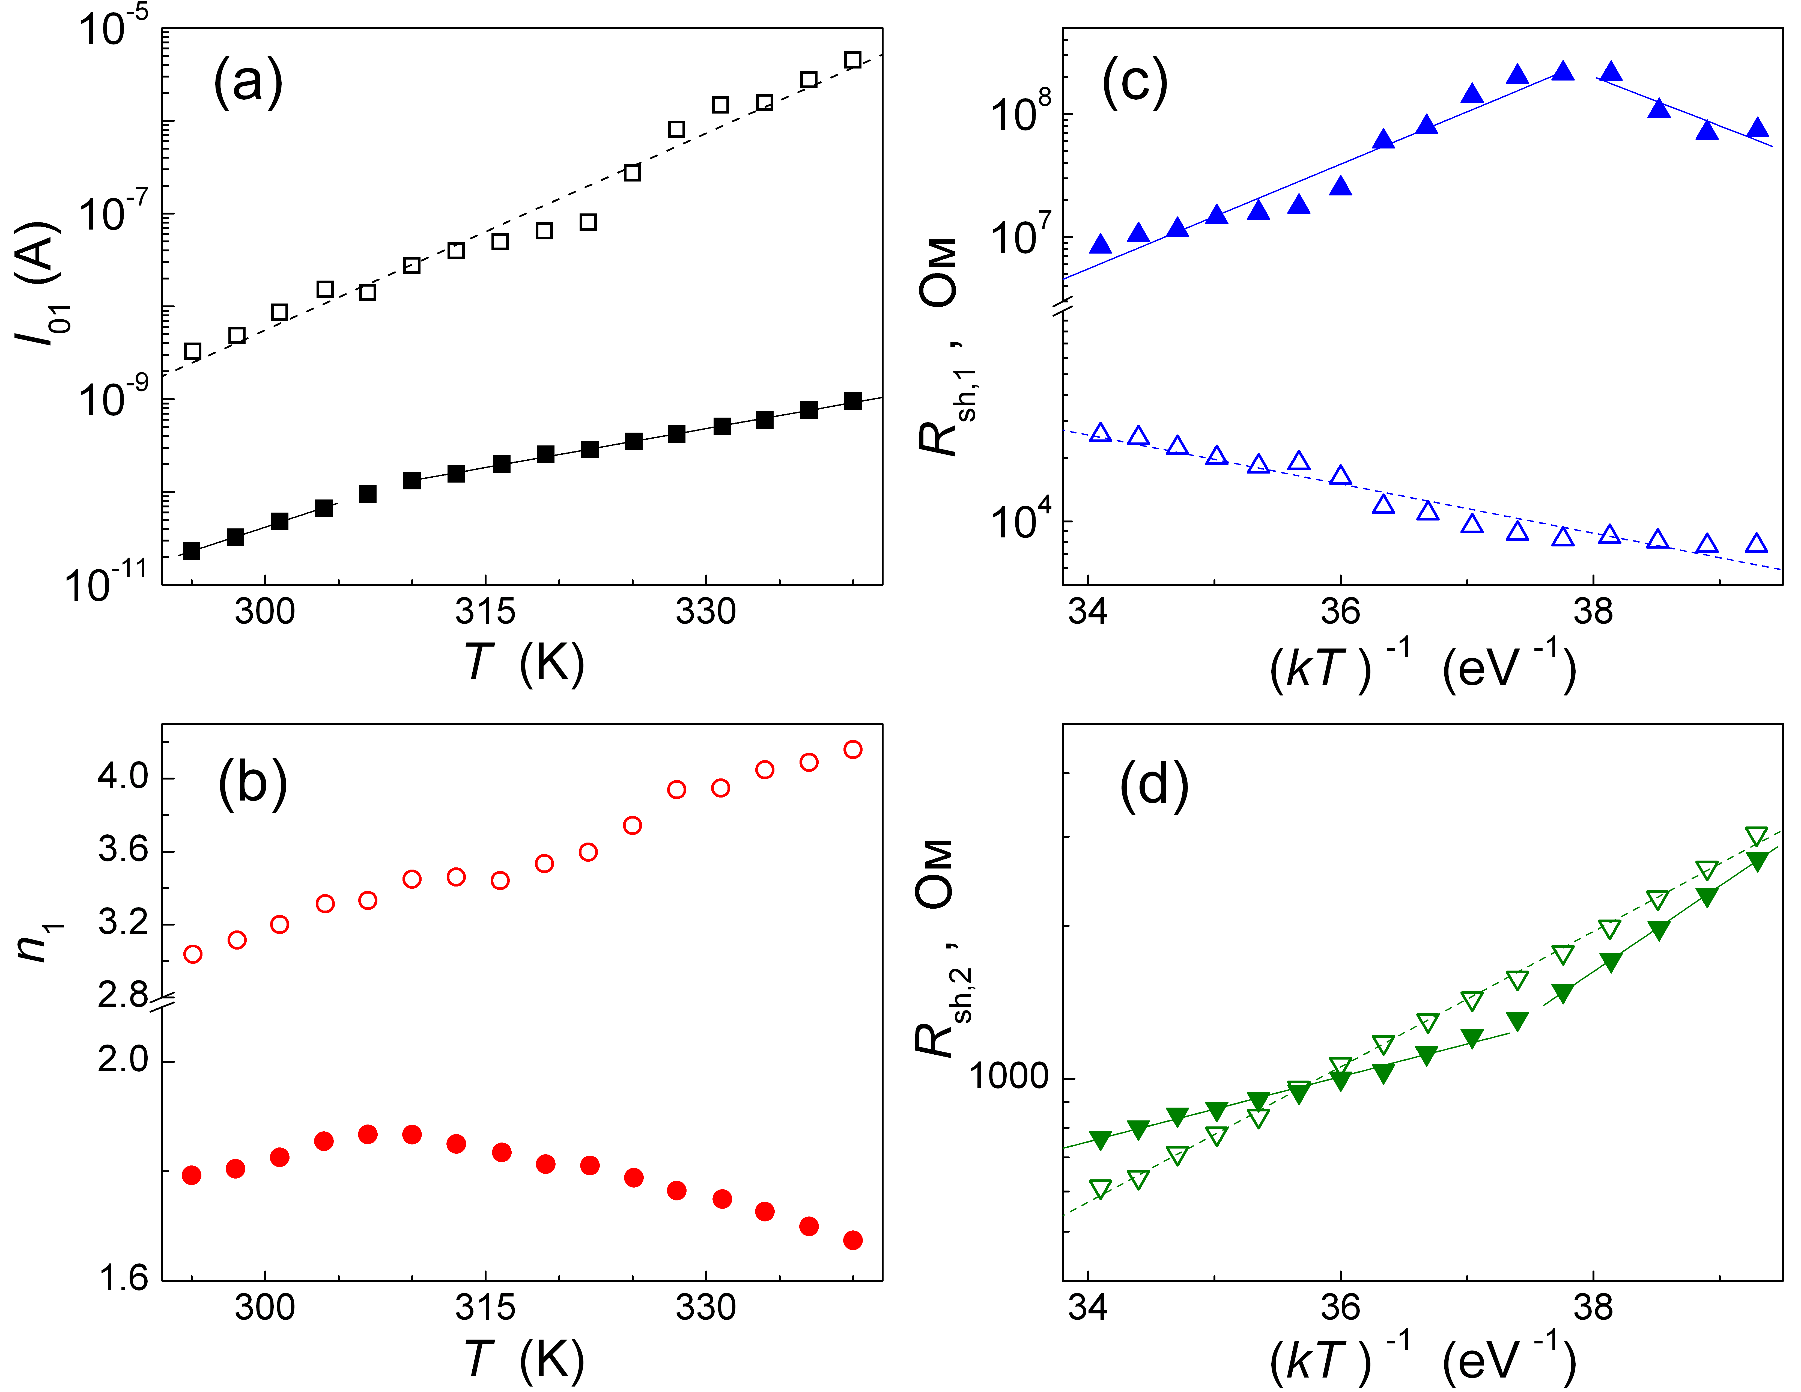
Figure 3. Temperature dependencies of D₁ saturation current (a), D₁ ideality factor (b), D₁ (c) and D₂ (d) shunt resistances. The marks are the experimental results, and the lines are the ﬁtted curves using linear approximation (panels a and b) or Eq. (5) (panels c and d). Open and filled marks corresponds to the iluumination and dark, respectively.

1. L. Zuo et al., Sol. Energy Mater. Sol. Cells. 122, 2014, 88.
2. F. A. de Castro et al., IEEE J. Sel. Top. Quantum Electron. 16, 2010, 1690.
3. B. Romero, G. del Pozo, B. Arredondo, Solar Energy 86, 2012, 3026.
4. K. Roberts, S. R. Valluri, arXiv preprint arXiv:1601.02679, 2015.
5. V.V.Brus et al., Semicond. Sci. Technol. 26, 2011, 125006

